Banc non empilable
(SRB160)

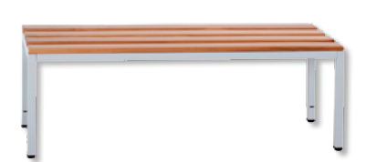

Banc non empilable
4 lattes, bois vernis

Dim. : L160xP40XH40cm

