INTER GTP SL PL64
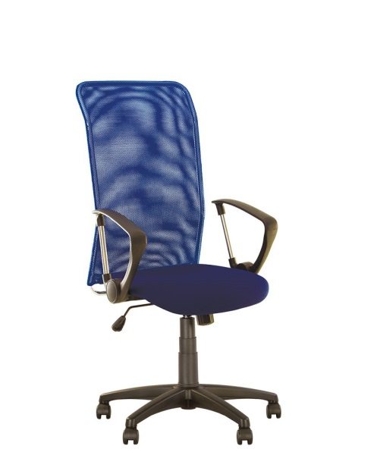
Computer chair INTER GTP SL PL64. The back of the chair is made of mesh which provides air ventilation, and the metal frame securely supports the spine.

MECHANISM –SYNCHRO TILT
Syncro tilt mechanism
OPENING ANGLE OF BACKREST/SEAT | YES  Backrest (19˚) Seat (7˚)
CHAIR HEIGHT ADJUSTMENT | YES
POSSIBILITY OF  BACKREST LOCK | YES (in one vertical position)
WEIGHT  ADJUSTMENT | YES  (by screw)
ANTI-SHOCK | NO
BACKREST HEIGHT ADJUSTMENT | NO
SEAT DEPTH ADJUSTMENT | NO

GENERAL CHARACTERISTICS
Seat width - 495 mm
Seat depth - 650 mm
Seat height in lowered position - 400 mm
Seat height in raised position - 500 mm
Product height in lower position - 1040 mm
Height of armrest in raised position - 745 mm
Product height in the upper position - 1175 mm
Height armrest in lower position - 645 mm
Backrest height minimum - 630 mm
Overall depth - 650 mm
Overall width - 650 mm
Base diameter - 650 mm
Maximal load 130 kg
Netto weight 12.9 kg
Brutto weight 14.5 kg

